Example of EBB Abstract Formatted for MS Word

1st Author
1st author's address
2nd Author
2nd author's address
3rd Author
3rd author's address

ABSTRACT
This abstract provides a sample of a Microsoft Word document with formatting guidelines for EBB abstracts of posters presented in this event.
This abstract style has a two column layout and must have 1 page at maximum. There should be only two sections in the abstract: Abstract and References. Please avoid the use of other sections.
The overall page format features are balanced double columns, a specified set of fonts (Arial or Helvetica and Times Roman) in certain specified sizes (for instance, 9 point for body copy), specified size of margins (2.54cm [1"] top and bottom and 1.9cm [.75"] left and right) and specified column width (8.45cm [3.33"]).
Tables and figures must be numbered. Their descriptions should follow them, as in the examples shown in Figure 1 and in Table 1.

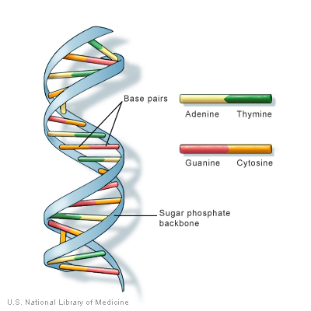
Figure 1 – DNA illustration (http://ghr.nlm.nih.gov/handbook/illustrations/dnastructure.jpg)

Font | Size | Local
Helvetica or Arial | 18 | Title
Helvetica or Arial | 12 | Authors
Times New Roman | 12 | Sections title
Times New Roman | 10 | Body of abstract
Times New Roman | 9 | Titles of figures and tables
Times New Roman | 9 | Body of references
Table 1 – Fonts types and sizes

REFERENCES
- ICOBICOBI Proceedings template. http://www.vision.ime.usp.br/~icobicobi/
- ACM SIG PROCEEDINGS template. http://www.acm.org/sigs/pubs/proceed/template.html.
- Conger., S., and Loch, K.D. (Eds.). Ethics and computer use. Commun. ACM 38, 12 (entire issue).
- Mackay, W.E. Ethics, lies and videotape... in Proceedings of CHI '95 (Denver CO, May 1995), ACM Press, 138-145.
- Schwartz, M., and Task Force on Bias-Free Language. Guidelines for Bias-Free Writing. Indiana University Press, Bloomington IN, 1995.

